Diagnosis & Management of Symptomatic Spinal Hematoma
Ariana Nelson, Honorio T. Benzon, and Rasha S. Jabri

INTRODUCTION
Spinal epidural hematoma (SEH) is an accumulation of blood in the loose areolar tissue btwn the vertebrae and the dura of the spinal canal.
Typically, a hematoma is asymptomatic, but in rare cases it will compress the spinal cord, w/ potentially devastating neurological consequences.
S/S:
- sensory disruption
- bowel & bladder incontinence
- motor weakness
- severe: complete paralysis of the affected limbs.

SEHs can be spontaneous or 2/2 invasive procedure ie: lumbar puncture, neuraxial anesthesia, or spine surgery. Hematoma more likely to be symptomatic in cervical & thoracic regions 2/2 more constricted spinal canal vs greater space for volume compensation in lumbar region - esp the cauda equina region.

SEH IMPLIED TO BE SYMPTOMATIC FOR THIS ARTICLE

SYMPTOMATIC SPINAL EPIDURAL HEMATOMA
Incidence
SEH etiology most often from procedure in/near epidural space. Ex: non-symptomatic SEH can technically be found on postop imaging in 33%-100% of pts after spinal surgery, but pts will rarely show any neuro deficit, w/ symptomatic SEH only ~0.2%.
Incidence of symptomatic SEH after neuraxial anes. approx 1 in 150,000 epidurals and < 1 in 220,000 spinals. But incidence may be increasing, can be 1:200,000 in OB, and up to 1:1000 w/ elderly women s/p lower extremity surgery.
This large disparity can be attributed to +/- risk factors in these pt populations. Pregnancy has relatively hypercoagulable state and OB pts also younger w/ a larger and more compliant epidural space than elderly pts.

Risk Factors
- Increasing age 2/2 reduced size of epidural space: equivalent vol of blood causes increased pressure in a smaller epidural space.
- No racial differences, but SEH more frequent in females, esp older females
  - Maybe 2/2 osteoporotic narrowing of the epidural space [both gender and age may contribute to > 50-fold increased likelihood of SEH after epidural anes. for knee vs epidural labor analgesia. ALSO, thromboprophylaxis necessary in ortho pts vs OB pts who do not require routine DVT prophylaxis.
HIGHEST SEH risk factor = physiologic or iatrogenic coagulation disorder:
- eg: liver disease, alcoholism, thrombocytopenia, or pharmacologic anticoagulation.
  - Recent retrospective study showed significant SEH increase after spine surgery in pts with Rh+ blood types, intraop blood loss > 1L, hgb< than 10 g/dL, and INR > 2.0 in the 1st 48 hrs.

Anticoagulant tx w/ neuraxial analgesia, as well as the length and intensity of anticoagulation = most significant risk factors for epidural hematoma.
- Approx 1/4 to 1/3 of all SEH cases are assc w/ anticoagulation therapy.
- ~ 87% SEH pts: either hematologic abnormality (anticoag or genetic) or a procedure complicated by technical difficulty.
- Neuraxial procedures avoided in pts who have recently undergone thrombolysis.
- Spontaneous hematoma rare, but assc w/ anticoagulation, thrombolysis, blood dyscrasias, coagulopathies, thrombocytopenia, neoplasms, vascular malformations, or vertebral hemangioma.

Etiology and Location of Hematoma
Proposed causes SEH:
- Trauma, anticoagulation, thrombolysis, lumbar puncture, epidural or spinal anes, interventional spine procedures or surgeries, coagulopathy or bleeding d/o, hepatic dx w/ portal htn, vascular malformation, disk herniation, Paget dx of vertebrae, Valsalva maneuver (eg:pushing in labor), and HTN.
Causes of spontaneous SEH:
- Clotting disorders, either acquired (eg, anticoagulant therapy, malignancies) or congenital (eg, hemophilia). Vascular malformations are rarely responsible for spontaneous epidural hematomas.
- Less-common predisposing factors: SLE, ankylosing spondylitis, RA, Paget disease, disk herniation, and HTN.

The dorsal venous plexus = implicated hemorrhage source:
- Plexus lacks valves and permits reversal in blood flow w/ increased IV pressure from physical activity.
- These veins lack protection, surrounded only by loose areolar tissue and are vulnerable to sudden increases in intra-abdominal or intrathoracic pressure, leading to rupture and hemorrhage.
- Epidural venous plexus most prominent in thoracic, and spont SEH most often occurs in thoracic and cervicothoracic region, followed by thoracolumbar area.
  - SEH typically posterior or posterolateral to thecal sac 2/2 firm adherence of the dural sac to the posterior longitudinal ligament on the ventral side of the spinal canal, preventing the accumulation of hematoma.
  - The dorsal aspect of the thoracic or lumbar region is commonly involved, and expansion is typically limited to only a few vertebral levels.
In pregnancy, proposed that increased venous pressure 2/2 uterine enlargement, combined w/ hemodynamic changes of pregnancy, may predispose to rupture of a preexisting pathologic epidural venous plexus wall.
- Venous source most widely accepted, but debate re: potential arterial source, as venous BP < intrathecal pressure; so although forward flow is possible into the low-pressure epidural space, venous blood could not cause spinal cord compression.

NYSORA Tips
-Hemorrhage into the spinal canal most commonly occurs in the epidural space bc of the prominent epidural venous plexus.
-SEH may be spontaneous or may follow minor trauma, such as lumbar puncture or neuraxial anesthesia.
-SEH occurs primarily in anticoagulated or thrombocytopenic pts.
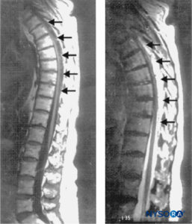

FIGURE 1. Sagittal MRI of thoracolumbar spine. A large complex epidural hematoma extending from T3 to T10 through T11 is seen with hypo- and isodense signal characteristics on a T1-weighted image (left; arrows) and hyperintense signal characteristics on a T2-weighted image (right; arrows). At the center of the hematoma, the spinal cord abuts the posterior aspect of the thoracic vertebral
bodies (left). No signal abnormalities of the cord itself are seen

History and Physical Examination

Classically presenting symptom of SHE: acute axial back pain that radiates to corresponding dermatomes and evolves to focal neurologic deficit with signs of nerve root or spinal cord compression. The pain generally described as a severe, localized constant back pain w/ or without a radicular component that may mimic disk herniation, esp in the lumbar spine.
- Back pain is amplified by percussion over the spine, and maneuvers that increase intraspinal pressure; eg: coughing, sneezing, or straining.
- A 2010 analysis showed lower extremity weakness is the most common presenting sign, although back pain is still a common early symptom.
  - Assc symptoms may include: numbness, weakness, and urinary or fecal incontinence.
The onset of pain is occasionally related to minor strain, such as with lifting, coughing, sneezing, or Valsalva maneuvers, although in the majority of cases the onset of pain is spontaneous.
Depending on the level and size of the hematoma, physical findings may include:
- Unilateral or b/l weakness, sensory deficits with unilateral or bilateral radicular paresthesias, alterations in DTRs, and alterations of bladder or anal sphincter tone.
- Signs of spinal cord and nerve root dysfunction appear rapidly and may progress to paraparesis or, in high thoracic or cervical locations, quadriparesis.
- In cases of SEH related to neuraxial anesthesia or lumbar puncture, the presence of new or progressive postoperative neurologic symptoms should alert the physician to a possible epidural hematoma.

NYSORA Tips
- The pt may present w/ a severe, localized, constant back pain w/ or without a radicular component that may mimic disk herniation.
- Assc symptoms may include weakness, numbness, and urinary or fecal incontinence.
- Return of sensory or motor deficit several hrs after spinal/epidural block has worn off (w/ or without back pain) is highly pathognomonic and should be considered and treated as spinal or epidural hematoma until proven otherwise.
- Neurologic recovery after conservative mgmt has been reported in pts w/ back pain and leg weakness without paralysis.
- Neurologic recovery can occur if surgery and decompression is performed within 36 hrs of a complete motor deficit and within 48 hrs of a partial deficit.
Diagnosis
Clinical findings of SEH usually include: back pain and motor/sensory deficits that may rapidly progress to paraplegia, quadriplegia, or autonomic dysfunction.
An epidural hematoma ordinarily presents within the first 24–48 hrs after a procedure. Any new or progressive neurologic symptoms warrant immediate clinical evaluation and diagnostic workup to rule out any space-occupying lesion, including epidural hematoma. A neurologic deficit occurring in the presence of epidural analgesia mandates immediate discontinuation of the infusion, with the catheter left in place, to rule out any contribution from the local anesthetic.
- If the epidural infusion is cause of the neurologic manifestation, a return of sensorimotor function will be noted. Otherwise, immediate workup w/ radiographic imaging and neurosurgery consult required to r/o evolving epidural lesion.
- In a pt w/ acute axial back pain w/ progression of neurologic deficits, immediate assessment for s/s nerve root and spinal cord compression required to differentiate miscellaneous lesions simulating SEH. The clinical presentation of a pt w/ suspected epidural hematoma may resemble: epidural abscess, spinal cord disease, neoplasm, or acute disk herniation.
Differential dx of new or progressive postop neuro s/s includes: surgical neuropraxia, prolonged/exaggerated neuraxial block, anterior spinal artery syndrome, exacerbation of a preexisting neurologic disorder, and a previously undiagnosed neuro condition.
- A CBC w/ PLT should be ordered to assess the extent of bleeding and to determine the presence of infection. PT and aPTT determine the presence of bleeding diathesis.
- Rapid radiologic eval essential to minimize delay in tx of SEH. MRI best for spinal emergencies 2/2 rapid, noninvasive eval of the vertebral column and the spinal cord in all planes. Spinal MRI may delineate location of epidural hematoma and identify an assc vascular malformation; MRI also provides info on extent of hematoma and degree of cord compression. MRI can also aid in assessing age of the hematoma.
CT scan may give false-negative if hematoma is isodense to the thecal sac or spinal cord and the image quality is affected by artifacts often seen in upper thoracic region. Spinal CT may be non-diagnostic in thoracic spine, where resolution is poorer than in lumbar and cervical spine 2/2 high contrast btwn lung parenchyma and vertebral bone. Conventional angiography may be required to definitively demonstrate the presence of a vascular malformation.
Prevention, Treatment, and Prognosis
Neuraxial procedures avoided in pts on anticoagulants, thrombolytics, or w/ suspected bleeding diathesis. Decision to perform neuraxial block and timing of catheter removal in a pt receiving antithrombotic tx made on an individual basis, weighing risks of spinal hematoma w/ benefits of regional anes. ASRA has published consensus statements on neuraxial anes and anticoagulation.
Urgent surgical decompression is tx of choice for SEH causing acute compromise of cord function.
- Laminectomy is followed by evacuation of the hematoma, coagulation of bleeding sites, and inspection of the dura.
- The dura is then tented to the bone, and, occasionally, epidural drains are employed for as long as 24 hrs.
  - Recovery after prolonged paralysis without surgery is rare, so surgical consult for emergent decompressive laminectomy ASAP
- The critical factors for recovery after SEH are:
  - Level of preop neuro deficit and the operative interval.
  - Prognosis for neuro recovery 1º depends on pt’s preop neuro status and duration of neuro dysfunction.
    - Prognosis worse if delay btwn injury and surgical intervention.
Previously, complete neurologic recovery considered unlikely if > 8 hrs btwn development of paralysis and surgical intervention. But recovery possible if surgery performed within <12 hrs of paralysis.
- Recent finding: recovery possible if surgery performed within 48 hrs of an incomplete motor deficit, and within 36 hours of a complete motor deficit.
  - Functional recovery after 72 hrs of symptoms has even been reported
- Still - appraisal of pt’s symptoms and emergency MRI take time, so consult w/ spine surgeon on potential emergent hematoma evacuation should be obtained ASAP
ccca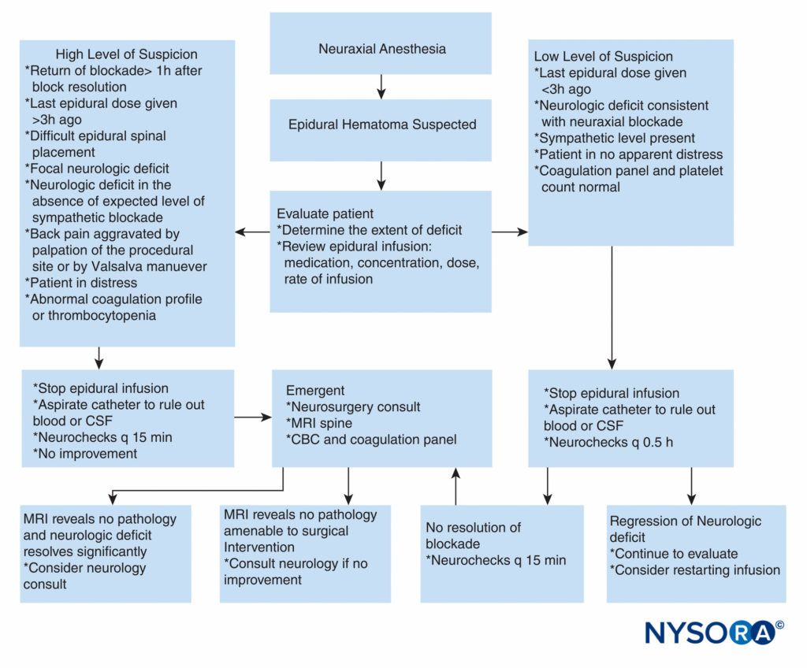
FIGURE 2. Practical approach to decision-making in workup and treatment of a patient with suspected epidural hematoma. CBC = complete blood cell count; CSF = cerebrospinal fluid; MRI = magnetic resonance imaging; q = every.

TABLE 1. Neurologic recovery in relation to timing of surgery.
Author | Interval between paralysis and recovery
Wulf⁶⁸ | 8 hrs 36 hrs of a complete  motor deficit
Lawton et al⁴⁸ | 12 hrs 48 hrs of an incomplete  motor deficit

Spinal Epidural Hematoma: Summary
SEH is a rare source of neurologic deterioration and can result in autonomic, sensory, and motor disturbance of varying degrees depending on location and size of hemorrhage. SEH may be acute or chronic, spontaneous, post-traumatic, or iatrogenic. Known risk factors include technically difficult neuraxial procedure, presence of intrinsic or acquired coagulopathy, female gender, and advanced age. Potential risk factors as evidenced by inconsistent data in literature include: low hgb, presence of Rh+ antibody, and anatomical abnormalities of the spinal cord. Given that SEH is a rare but potentially reversible cause of spinal cord compression, it is essential that the dx be made without delay to enable full recovery. Spinal hematoma may occur even in the absence of identifiable risk factors; therefore, providers must maintain a high index of suspicion and vigilance in monitoring for new neurologic symptoms.
Although MRI cannot be conducted with the rapidity of a CT scan, it is the diagnostic modality of choice because it is both sensitive and specific. Swift detection of neurologic deterioration is critical to early diagnostic imaging and prompt intervention. It is reassuring to note that recovery can occur without surgery in the absence of paralysis. When paralysis occurs, surgical decompression of the spinal cord and nerve roots can result in full functional recovery when accomplished within a reasonably rapid interval. If intervention is delayed, permanent sequelae of SEH can include: sensory deficits, paraplegia, spasticity, neuropathic pain, and urinary or anal sphincter dysfunction.

